Scenario No: 1
1. Domain: whizminder.com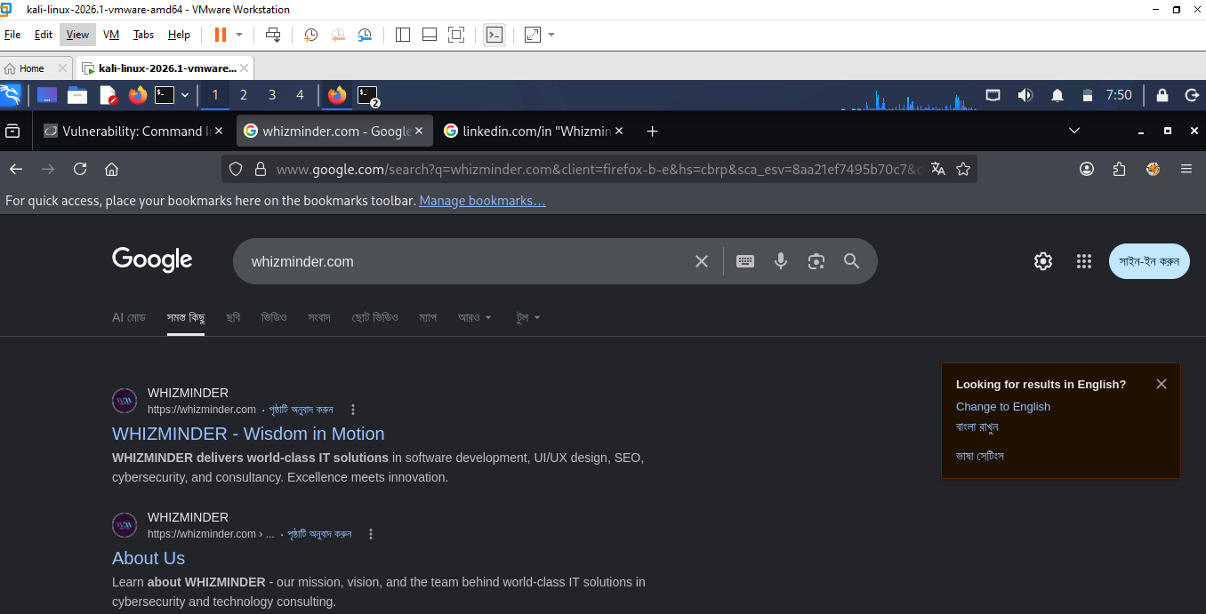

Sub-domain: www.whizminder.com, cdn.whizminder.com, mail.whizminder.com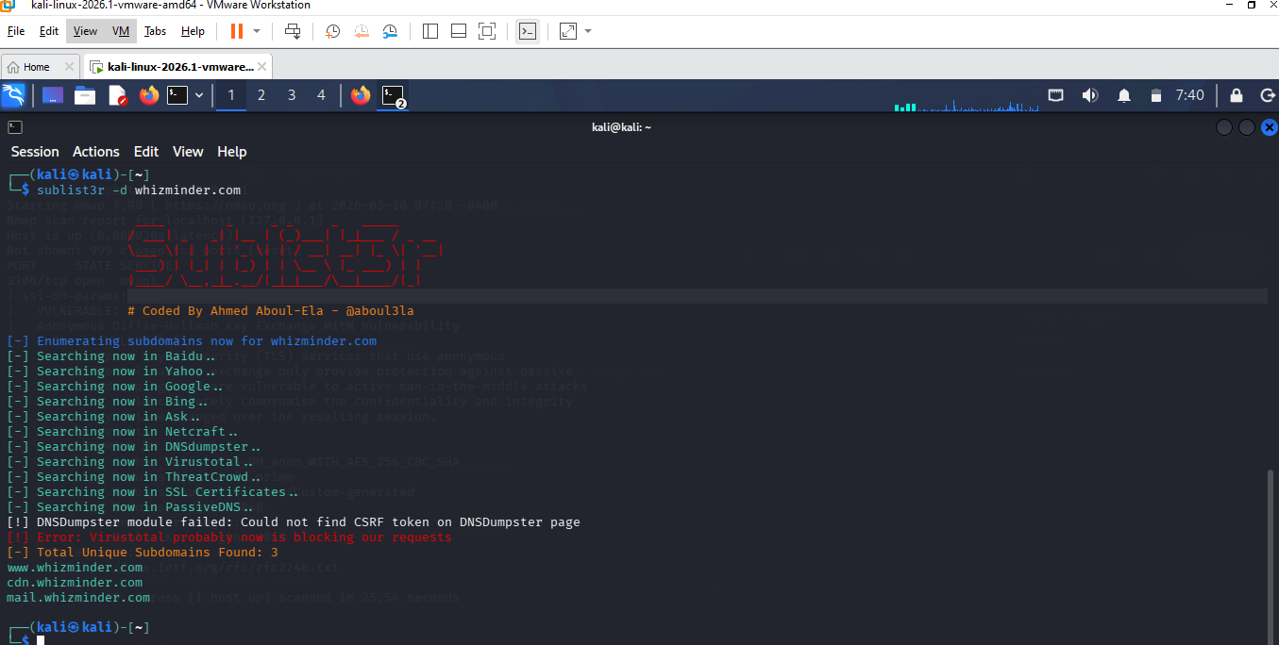
Use mail.whizminder.com
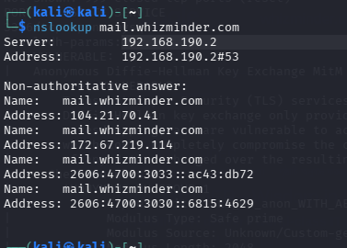
IP : 104.21.70.41
Use www.whizminder.com
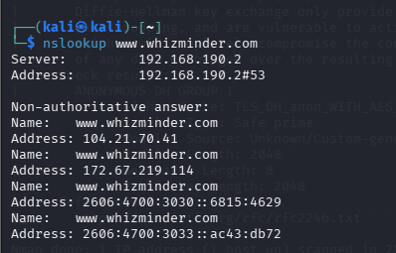
IP : 104.21.70.41

2.
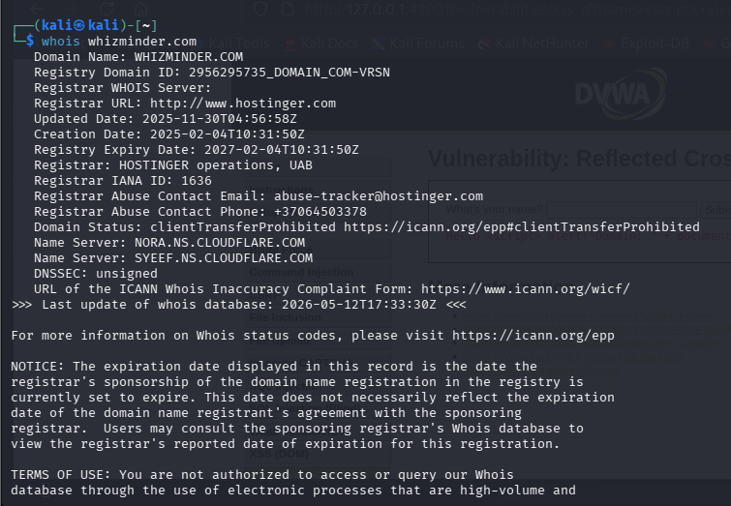
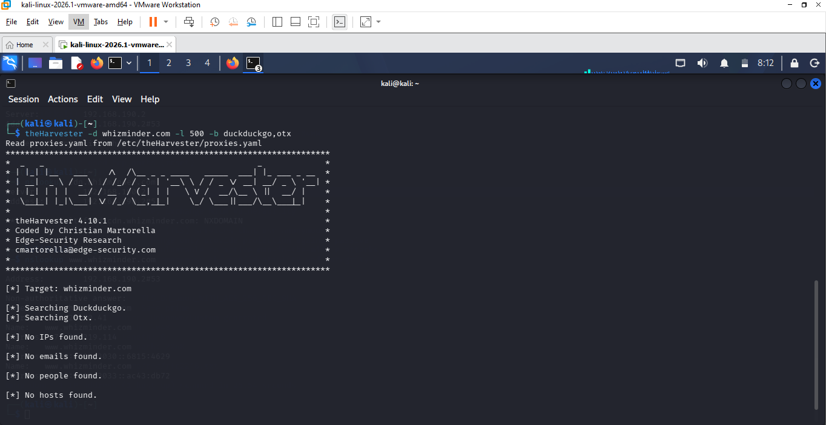
No IPS,Email,people
Scenario No: 2
1. Nmap
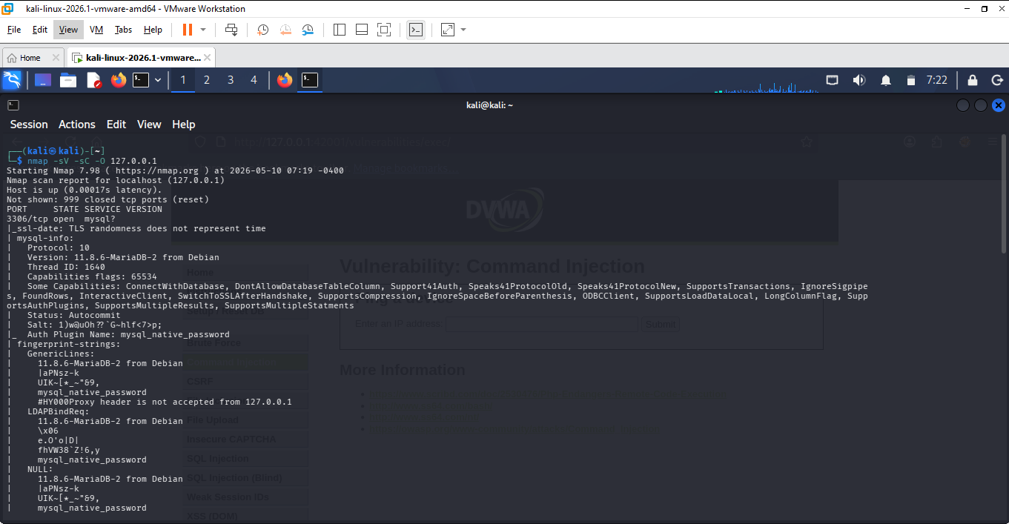
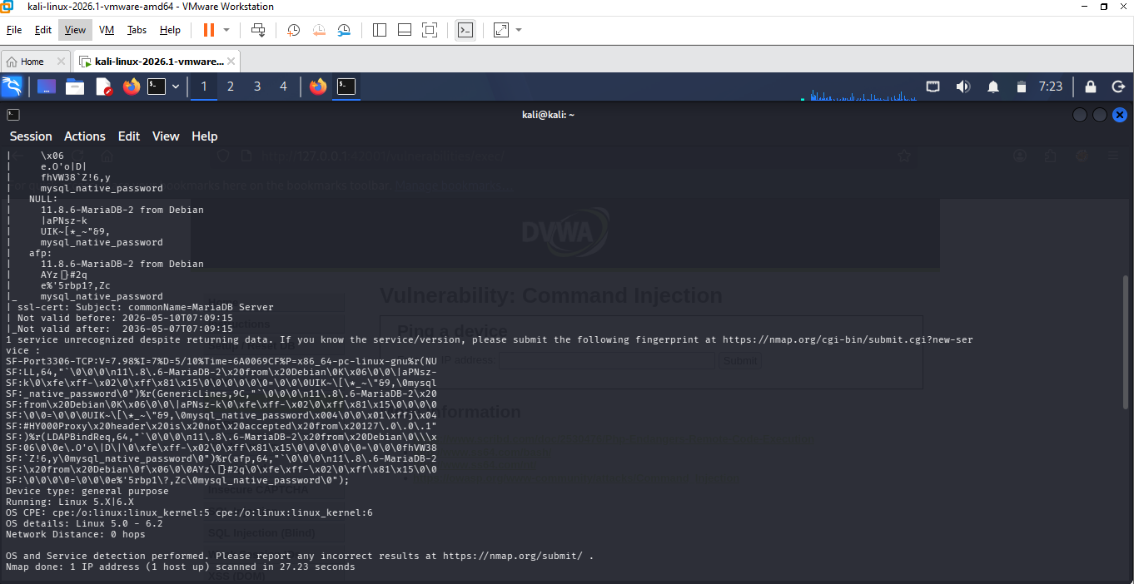
IP: 127.0.0.1 port 3306
2. Nmap Vulnerability scan 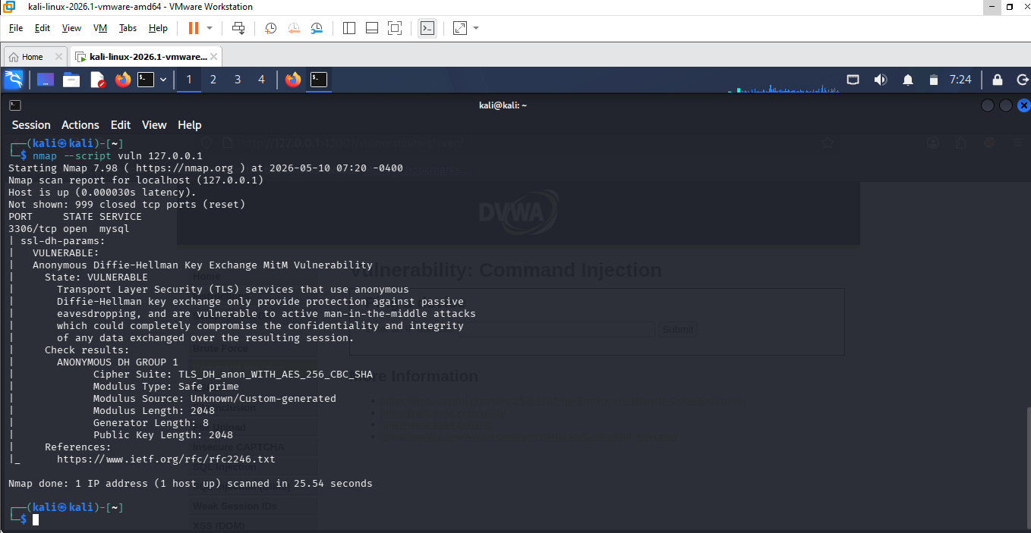
Weakness : Anonymous Diffie-Hellman Key Exchange
Scenario 3.
1. Meterpreter Reverse Sell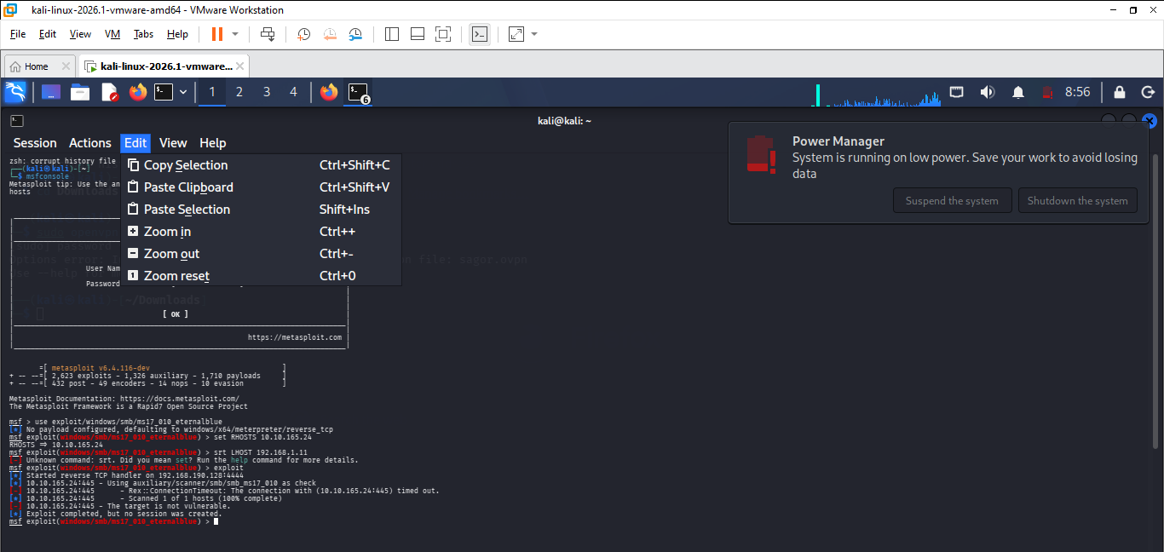
2. Cookie
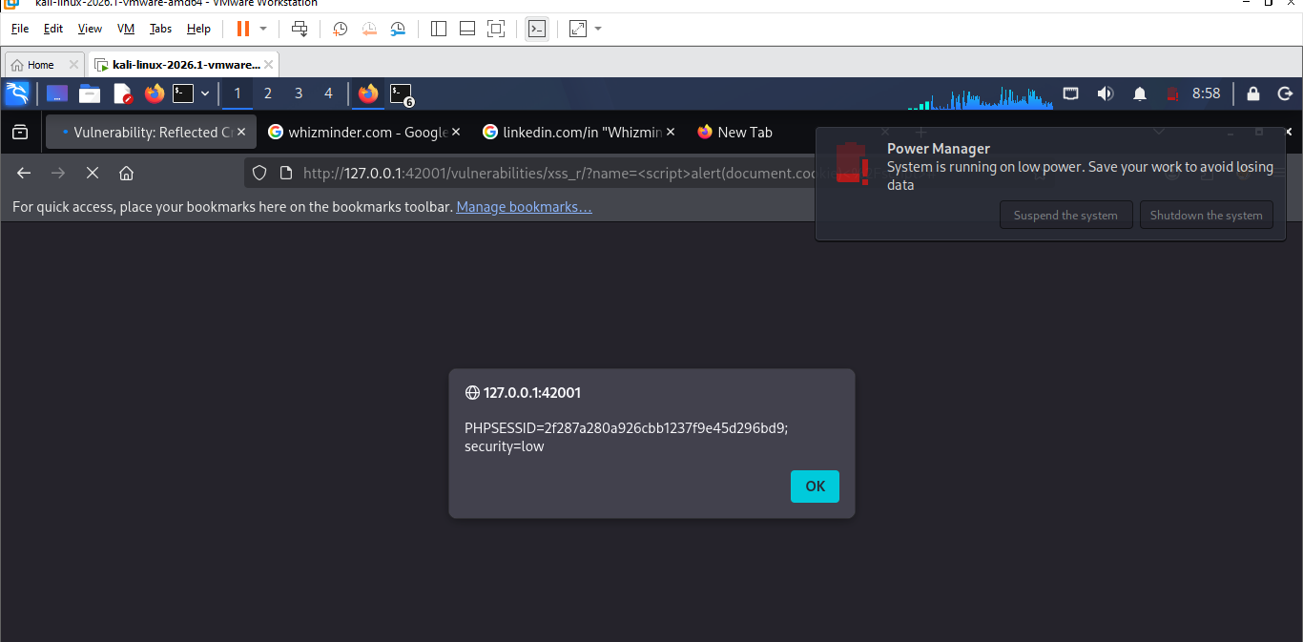
Risk PHPSESSID

3. CSRF
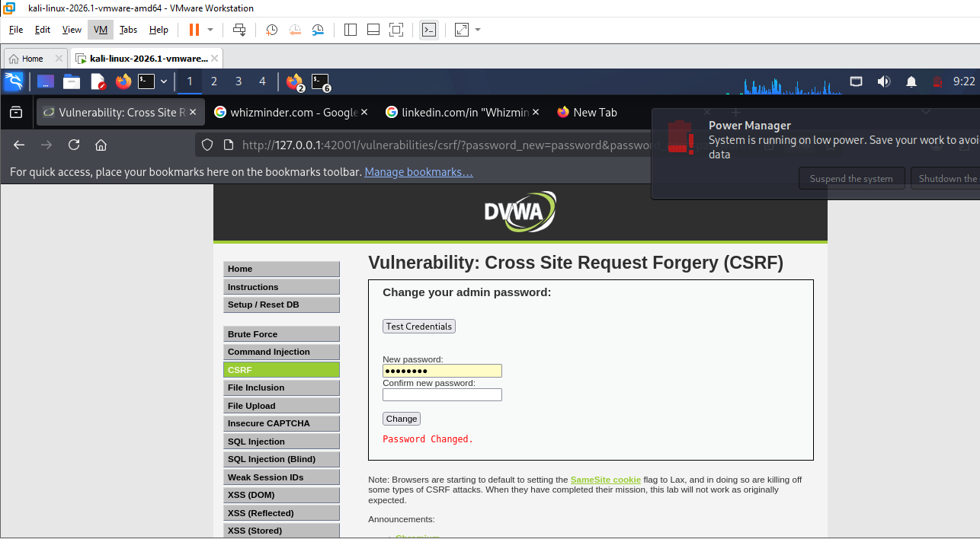
Password Changed
4.SQL injection
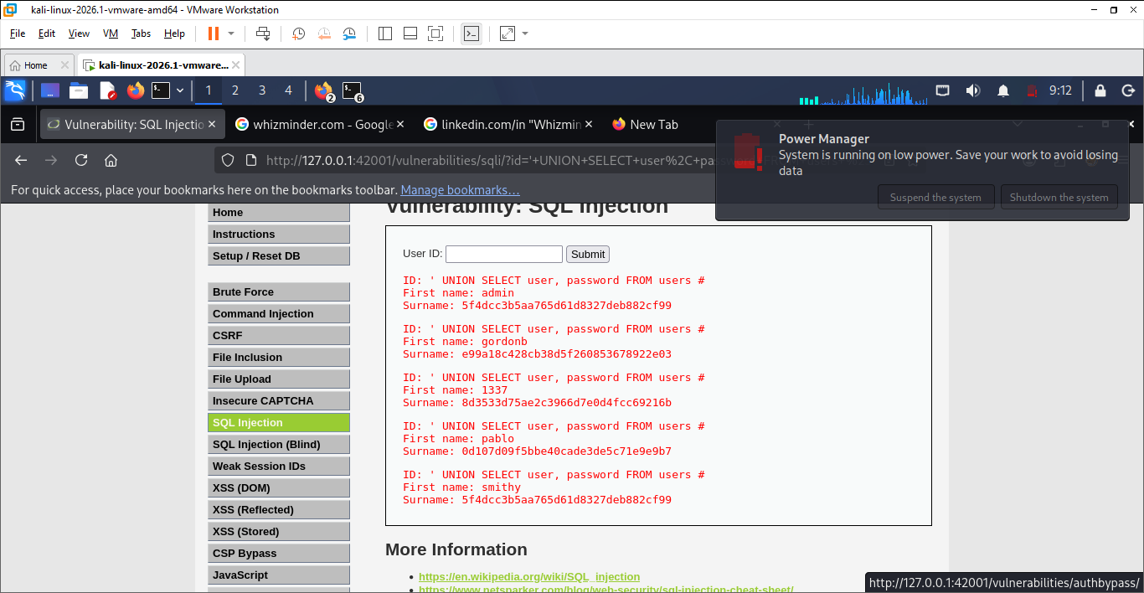
Use ' UNION SELECT user, password FROM users #
Then show all users name and others.

5. Local File Inclution
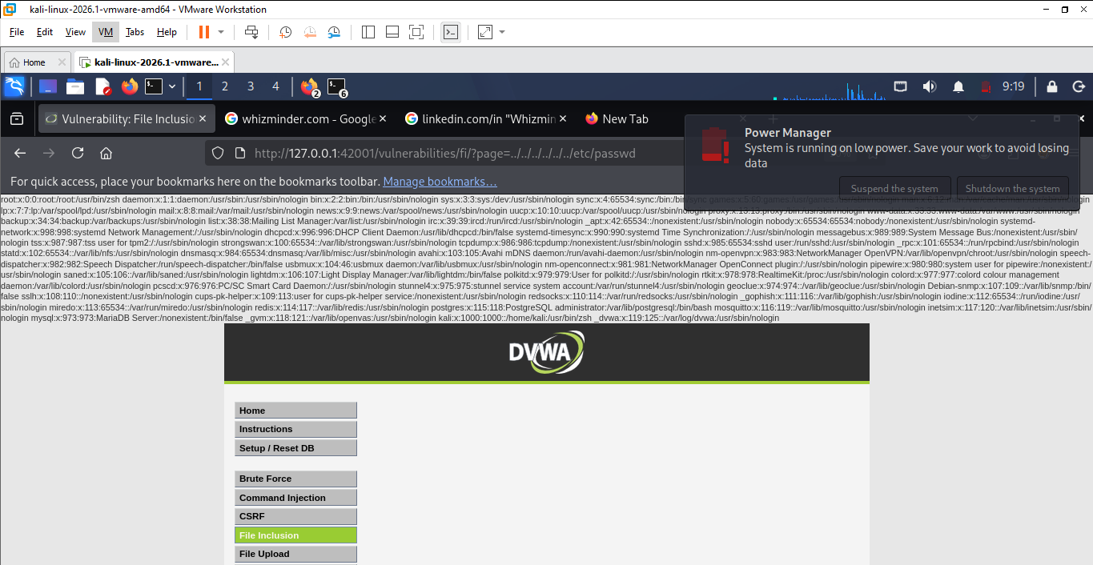
../../../../../../etc/passwd
Use this the read password file.

Scenario 4:
1. Task 1: Information Gathering & Reconnaissance
Summary: We used tools like Sublist3r and theHarvester to find subdomains and employee information for whizminder.com. While some public data was found, no sensitive internal emails were exposed.
Risk Level: Low
Task 2: Scanning & Service Enumeration
Summary: Using Nmap, we scanned the target network to identify open ports and active services. This helped us find potential entry points, like the SMB service, which needs proper monitoring.
Risk Level: Low to Moderate
Task 3: Exploitation & Vulnerability Analysis
Summary: We simulated an attack using the EternalBlue exploit in Metasploit and tested web flaws (SQLi, XSS) in DVWA. The simulation proved that unpatched systems are at high risk of a full takeover.
Risk Level: High (Mitigation Required)
Overall Risk Assessment
The overall security posture is Moderate. While the reconnaissance phase showed low risk, the technical vulnerabilities in the servers (like EternalBlue) require immediate patching and better firewall rules to ensure data safety.

